Ideation Phase
Brainstorm & Idea Prioritization

Date | 27 June 2025
Team ID | LTVIP2025TMID53099
Project Name | OrderOnTheGo
Maximum Marks | 4 Marks

Brainstorm & Idea Prioritization Template:
As we brainstormed ideas for OrderOnTheGo, our team actively participated in sharing thoughts and suggestions. We took turns explaining each idea, while naturally grouping similar concepts together. This helped us identify common themes and structure our project better.
Once all ideas were shared, we organized the sticky notes into clusters based on their functional relevance. Each group was given a clear, descriptive label to reflect its core theme—like User Flow, Restaurant Management, or Admin Features.
This approach gave us a clear overview of our app’s core modules and made it easier to move into prioritization and planning.
Link: https://drive.google.com/file/d/1joWzQ1rh--Oos43iDQ6M8eWeo6-x0Vc-/view?usp=sharing
Reference: https://www.mural.co/templates/brainstorm-and-idea-prioritization
Step-1: Team Gathering, Collaboration and Select the Problem Statement

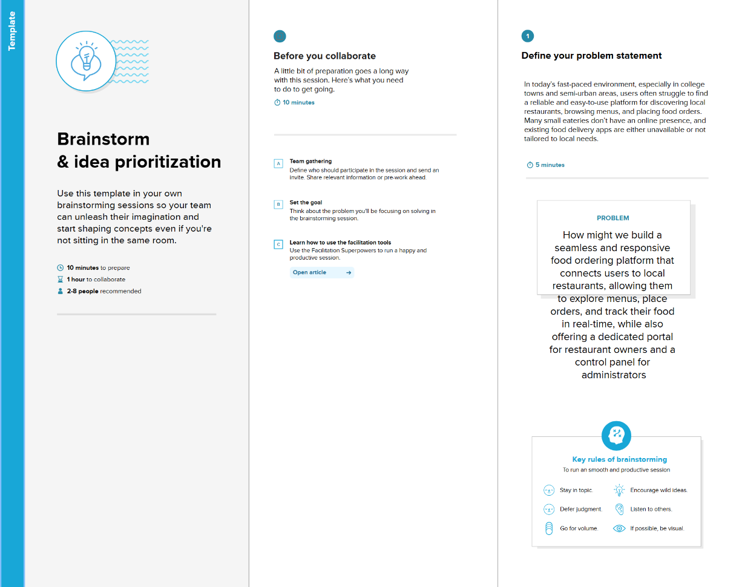
Step-2: Brainstorm, Idea Listing and Grouping
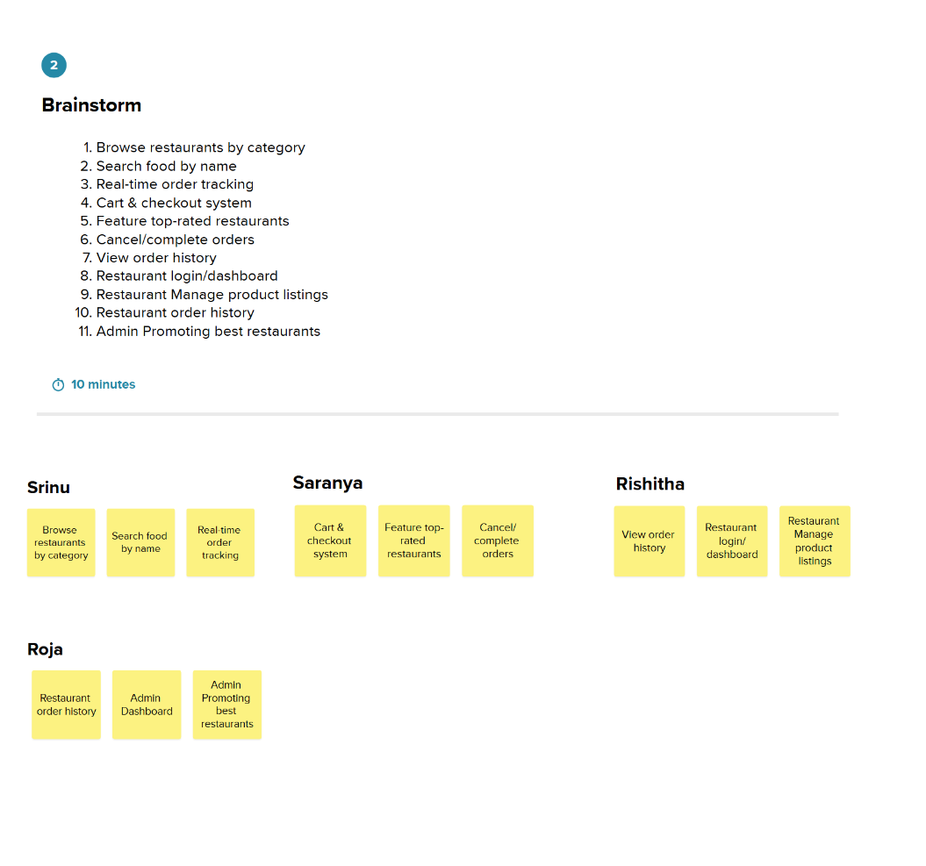
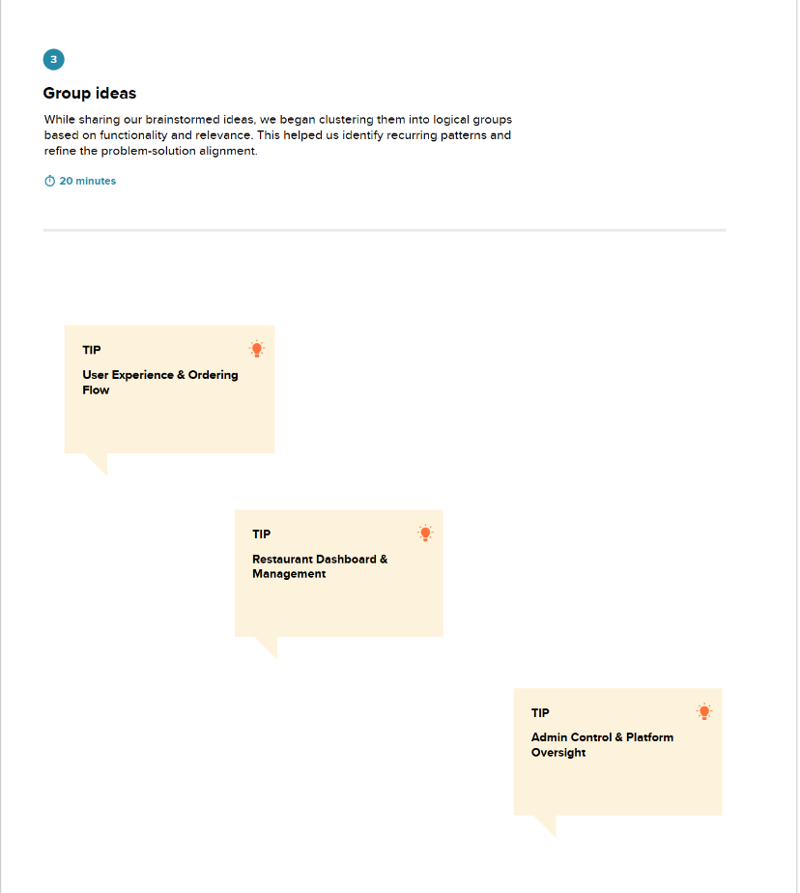

Step-3: Idea Prioritization
